1.

用一条*SQL* 语句 查询出每门课都大于*80* 分的学生姓名

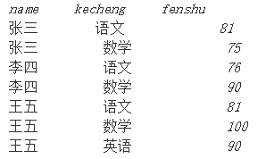

select name from table group by name having min(fenshu)>80;

select distinct name from table where name not in(select distinct name from table where fenshu<=80);

2.

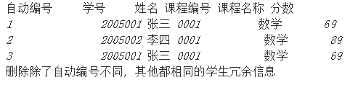

delete from table where 自动编号 not in(select min(自动编号) from table group by 学号，姓名，课程编号，课程名称，分数)

3.

一个叫 *team*的表，里面只有一个字段*name,* 一共有*4* 条纪录，分别是*a,b,c,d,* 对应四个球对，现在四个球对进行比赛，用一条*sql* 语句显示所有可能的比赛组合*.*

*select a.name,b.name from team a,team b where a.name<b.name*

*4.*

请用*SQL* 语句实现：从*TestDB* 数据表中查询出所有月份的发生额都比*101* 科目相应月份的发生额高的科目。请注意：*TestDB* 中有很多科目，都有*1* －*12* 月份的发生额。

*AccID* ：科目代码，*Occmonth* ：发生额月份，*DebitOccur* ：发生额。

数据库名：*JcyAudit* ，数据集：*Select \* from TestDB*

*select \* from TestDB a,(select Occmonth, max(DebitOccur) as Debit101Occur from TestDB where AccID=101 group by Occurmonth) b where a.Occurmonth=b.Occurmonth and a.DebitOccur>b.Debit101Occur*

*5.*

面试题：怎么把这样一个表儿

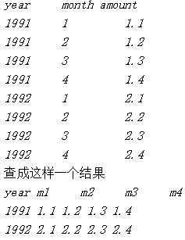

select year,

(select amount from table where month=1) as m1,

(select amount from table where month=2) as m2,

(select amount from table where month=3) as m3,

(select amount from table where month=4) as m4

from table group by year

6.

说明：复制表*(* 只复制结构*,* 源表名：*a*新表名：*b)*

*SQL:*

*select \* into b from a where 1<>1 (where 1=1是copy表结构和数据)*

oracle:

create table b as select \* from a where 1=2

7.

说明：拷贝表*(* 拷贝数据*,* 源表名：*a*目标表名：*b)*

*insert into b(a,b,c) select d,e,f from a;*

*8.*

*外连接查询( 表名1 ：a表名2 ：b)*

*mysql:*

*select a.a, a.b, a.c, b.c, b.d, b.f from a left outer join b on a.a=b.c;*

*oracle:*

*select a.a, a.b, a.c, b.c, b.d, b.f from a,b where a.a=b.c;*

*9.*

日程安排提前五分钟提醒

*select \* from table where datediff('minute',f 开始时间,getdate())>5*

*10.*

两张关联表，删除主表中已经在副表中没有的信息

delete from info where not exists (select \* from infobz where info.infid=infobz.infid)

11.

有两个表*A* 和*B* ，均有*key* 和*value* 两个字段，如果*B* 的*key* 在*A* 中也有，就把*B* 的*value* 换为*A* 中对应的*value*

这道题的*SQL* 语句怎么写？

update B set B.value=(select A.value from A where A.key=B.key) where B.id in (select B.id from B,A where B.key=A.key);

12.

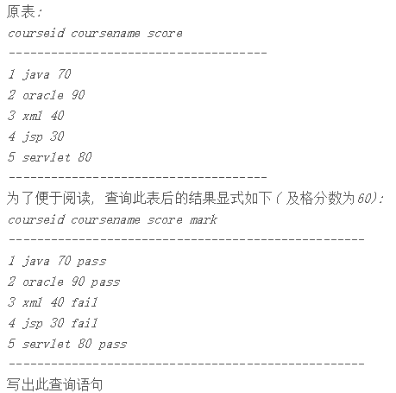

select courseid,coursename,score,case when score>=60 then 'pass' else 'fail' end as mark from course;

*select courseid, coursename ,score ,decode*（*sign(score-60),-1,'fail','pass') as mark from course*

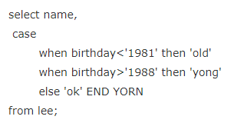

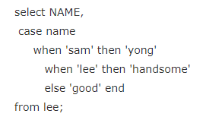

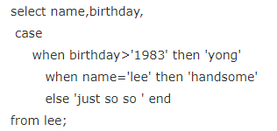

*12.*

select \*
from A
where 数量>8
compute max(数量),min(数量),avg(数量)

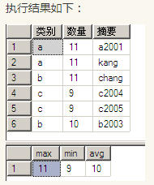

select \*
from A
where 数量>8
order by 类别
compute max(数量),min(数量),avg(数量) by 类别

